EXPERIMENT 17(VEHICLE REGISTRATION SYSTEM)

1) USE CASE DIAGRAM

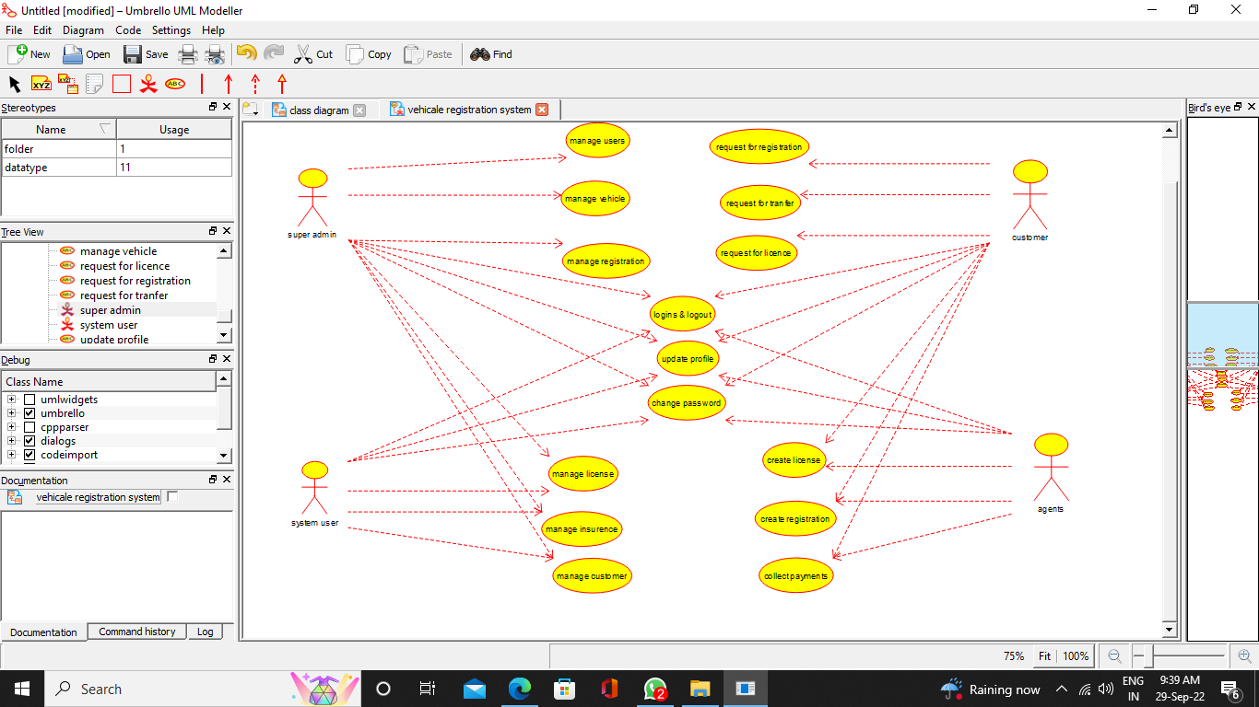

2) CLASS DIAGRAM

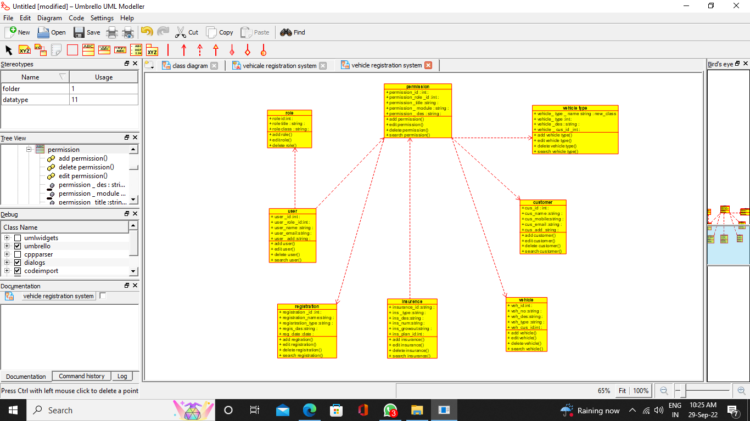

3) ACTIVITY DIAGRAM

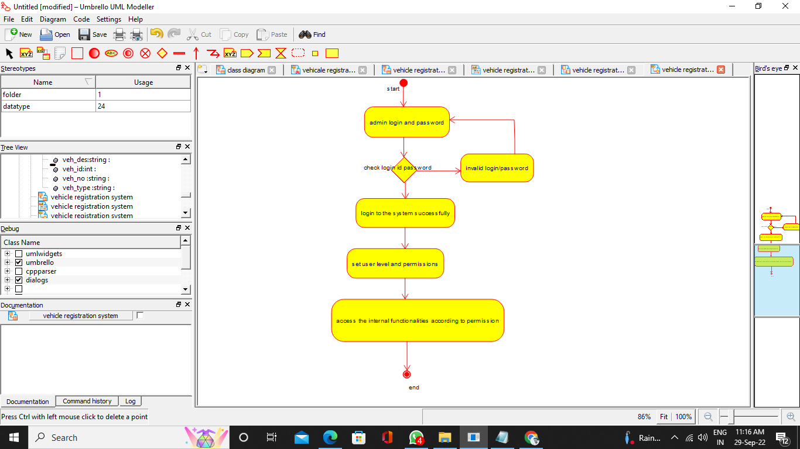

4)SEQUENCE DIAGRAM

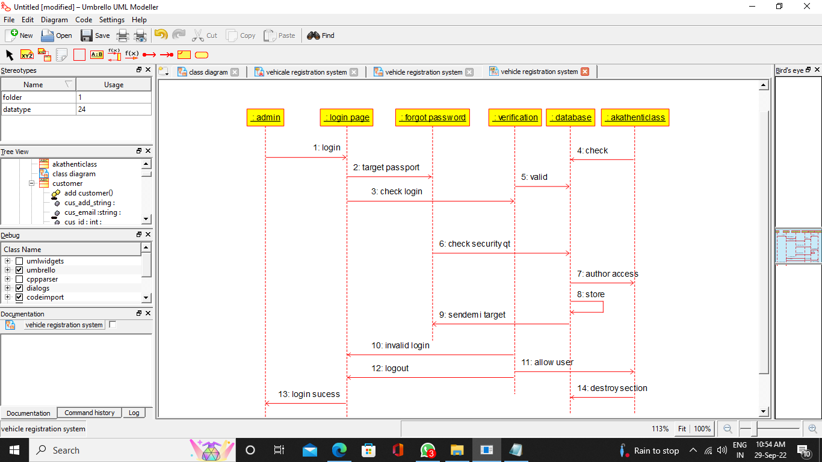

5) COLLABORATION DIAGRAM

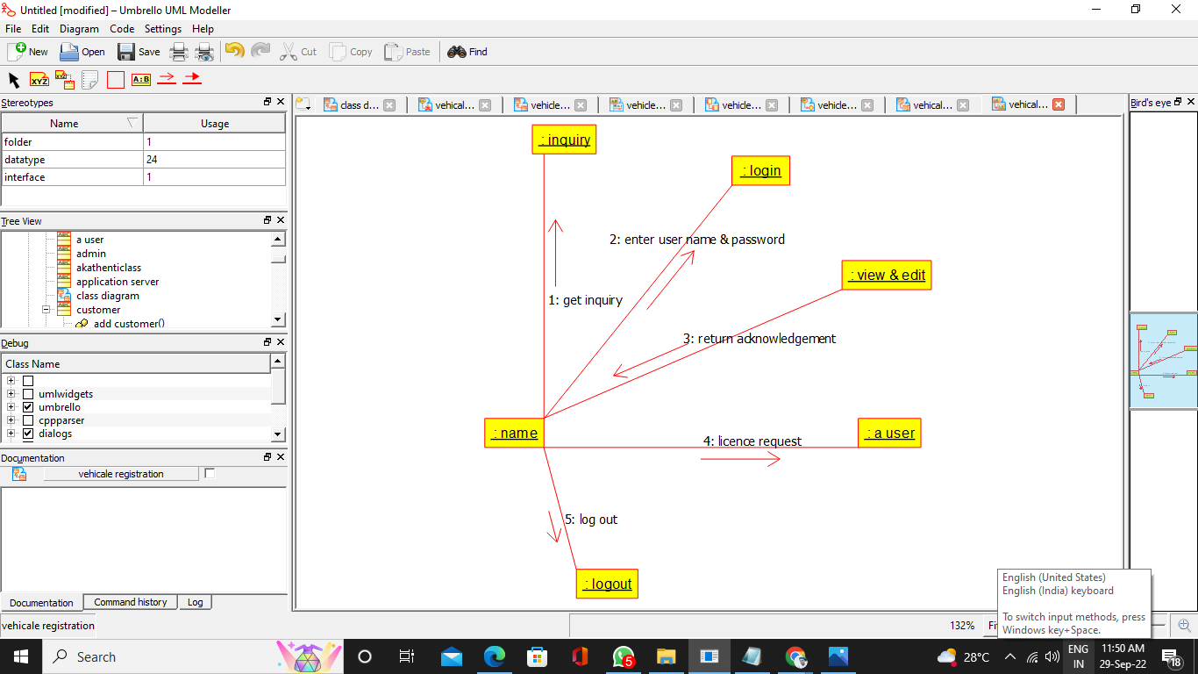

6) COMPONENT DIAGRAM

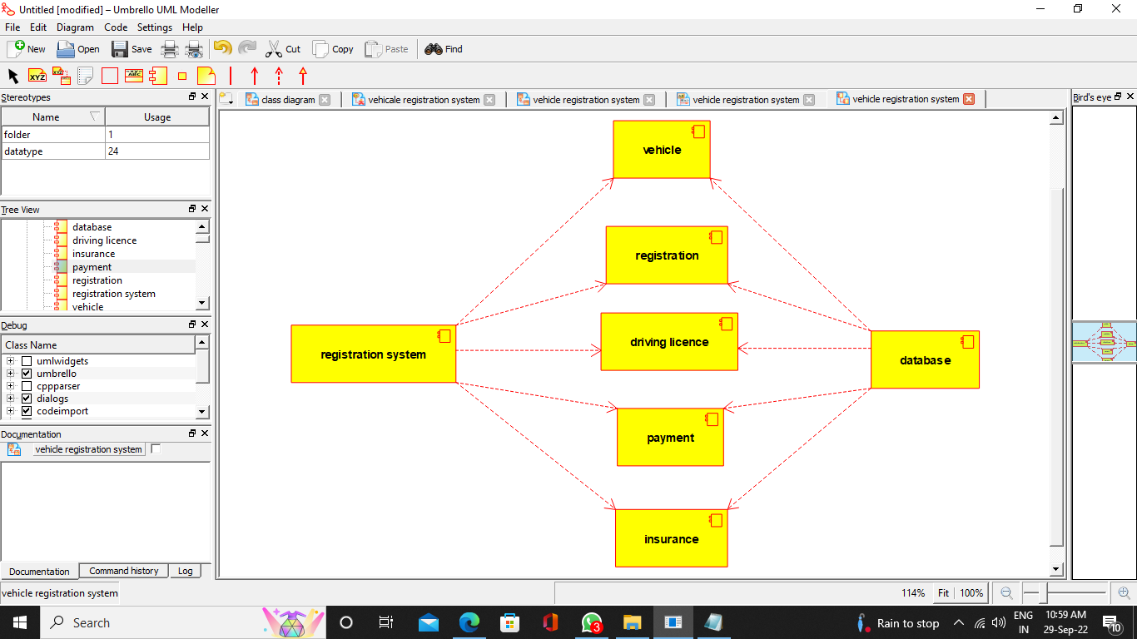

7) DEPLOYMENT DIAGRAM

